
Application and Measurement of Strain Gages

Procedure:

Part 1: Surface Preparation and Attaching the Strain Gage

- Surface Preparation
- Degrease the surface of the can. This will chemically clean the surface. Spray the degreaser onto a gauze pad and rub a side of the can. The area that you degrease should be about 3 inches tall and 2 inches wide. This will become your working surface. Figure 1 shows an example of the surface after preparation.
- Sand down the can. Start with the 320 grit sandpaper and scratch off the paint on the can so that you are left with only the aluminum exterior on your degreased 3” x 2” working surface. Then apply 2-3 drops of conditioner to the working surface and rub the can with a new piece of 320 sandpaper. Finally, use the 400 grit sandpaper (don’t apply anymore conditioner). Dry with a gauze pad. Be sure to wipe in one direction and change out gauze pads after each swipe to avoid re-contaminating the area.
- Apply 4-5 drops of conditioner to the working surface and rub with the cotton-tipped applicator. Change cotton-tipped applicators once one becomes discolored. Continue until a new, clean tip no longer discolored.
- Apply 4-5 drops of neutralizer to the working surface, scrub with a cotton-tipped applicator. This will set the surface to a pH level idea for bonding.
- Dry area with gauze pad. Be careful to only swipe in one direction and change gauze pads to avoid re-contaminating the area.
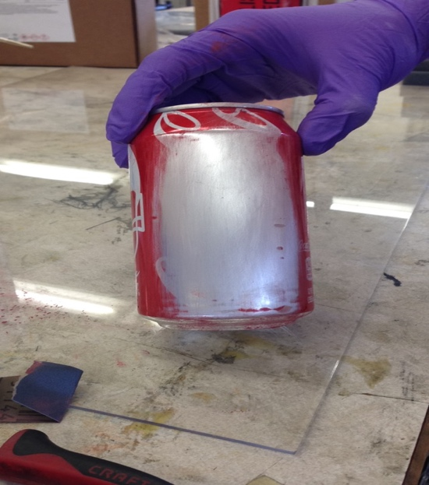
Figure 1: Soda can after degreasing, sanding and neutralization
- Attaching the strain gauge
- At your station, there is a sheet of plastic (clear or white) on the table to assist with strain gauge application. Apply 2-3 drops of neutralizer to a 4” by 4” space on the plastic sheet, then rub dry with a gauze pad. Grab a pair of tweezers, and wipe the tips with a gauze pad wetted with neutralizer.
- Remove strain gauge from the packaging, and lay it on the neutralized plastic working area with the copper tabs facing up.
- Apply clear tape over the strain gauge.
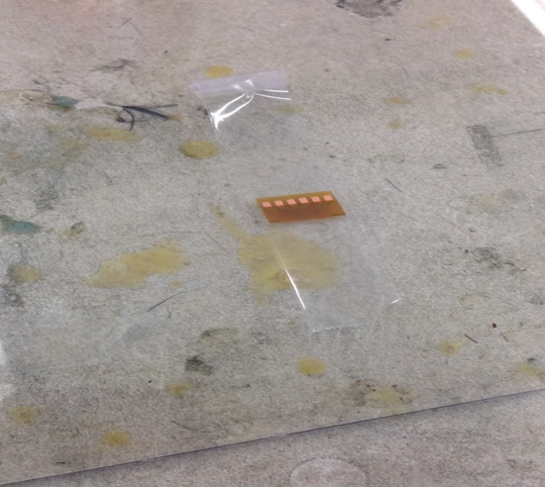

Figure 2: Clear tape applied to strain gauge
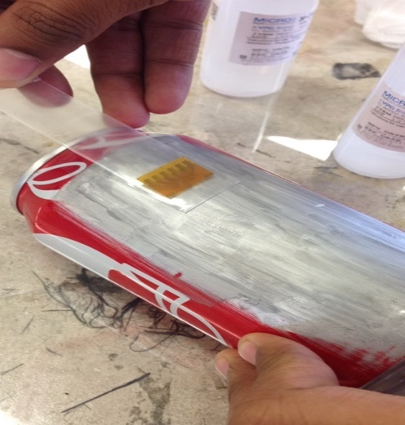
- Lift the tape up and transfer the taped strain gauge to prepared soda can surface. Be sure that the strain gauge is mounted vertically so that the copper tabs are facing downwards towards the bottom of the can. Pull the tape up so that the strain gauge is lifted up off the surface and there is about ¼ in between the surface and the gauge.

Figure 3: Tape lifted off the surface with a ¼ in. gap
- Apply a thin coat of catalyst (blue liquid) to the bonding side of strain gauge. Wait 60 seconds.
- Add 1-3 drops of adhesive onto the surface beside the tape.
- Fold tape back slowly onto the surface of the can, spreading adhesive under strain gauge as the tape touches the surface. Apply pressure to the strain gauge with your thumb for 60 seconds. After 60 seconds, remove your thumb in a twisting motion.
- Wait 2 minutes, then SLOWLY remove tape. It is helpful to remove tape from the end of the strain gauge without the copper tabs from a diagonal angle.
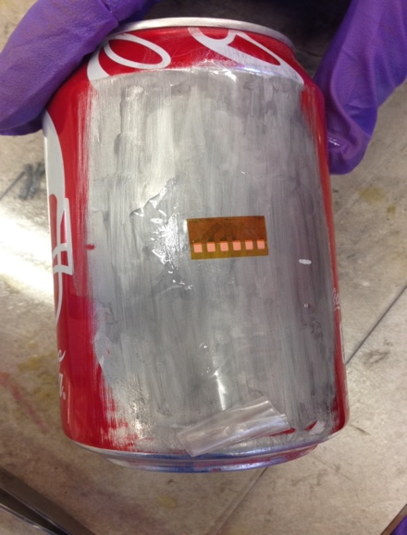
Figure 4: Fully mounted strain gauge
- Get a set of bondable terminals: these are copper tabs placed below the strain gage that serve as a connection point between the strain gauge and the wiring to the circuit.
- Repeat Part B for the bondable terminals, placing them 1 inch below the strain gauge.

- Soldering Connections

- Cut 6 pieces of the thin, red lead-wire. Each should be about 1.5 in long. These will connect between the copper tabs on the strain gage and the bondable terminals.
- There is a tiny layer of insulation on the wire, you must remove that from the end of the wire in order to effectively solder it to the strain gauge. Remove it using some sandpaper. After removing the insulation, the copper wire will be exposed.
- Solder one end of the the red lead-wire to the copper tabs on the strain gauge and the other to each pad of the bondable terminals.
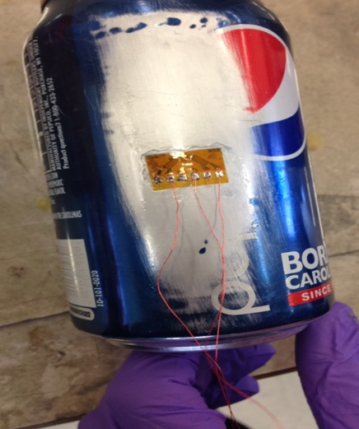

Figure 5: Red lead-wires soldered on strain gauge
Your group should have several pairs of twisted wire. This will be soldered to the bondable terminals and connect to the circuit. You will need one pair of wires per strain gage (for example, the rosette needs 3 pairs of wires)
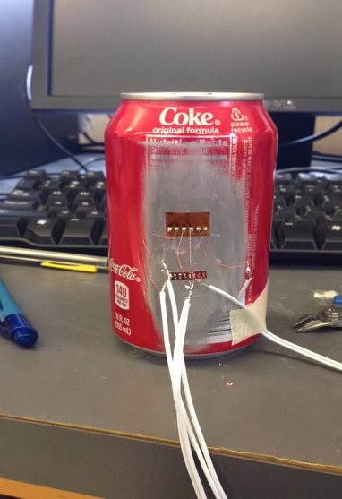
- Solder the twisted wire to the bondable terminals. The other ends of the wire will connect to the circuit in the next part of the lab.
Figure 6: Fully soldered connections

- Applying the Protective Coating

- Clean the area with a thin layer of rosin solvent.
- Tape a perimeter around only the strain gauge using the drafting tape, apply the polyurethane protective coating to the strain gauge.
- Allow to air dry for 20 minutes.
- The strain gage is now ready for measurement.
Any of the above steps not completed during lab will need to be completed before the next lab session.
- Do not forget to apply the polyurethane protective coating before Week 2.
- DO NOT attempt to solder any part of the strain gage while the urethane is uncured (needs at least 20 minutes to cure).

Part 2: To be completed on Monday, Sep 30

- Connecting the Circuit

The DAQ system that you will be using to measure the strain utilizes a National Instruments 9237 card, which is made specifically for strain gauge measurements. The NI 9237 card provides an internal voltage excitation and contains internal connections for Wheatstone bridge completion, but there are several external connections that must be made. For your mini-challenge, you completed a wiring schematic for the circuit. Wire up the strain gage circuit using the blue blocks (which are pinouts for the RJ-50 cables).

The type of the Wheatstone bridge refers to the number of active elements, and since you will be using one strain gauge per channel, you will be using a Quarter bridge configuration. However, we will not be using the 9945 connector piece, so you will have to complete the circuit using a Half bridge configuration and a dummy resistor (with the same resistance as the strain gauge) as R3 (this is called Quarter Bridge II).

Rosette/Tee Strain Gage Information
Gage Factor | 2.12
Nominal Resistance | 120 ohms
Poisson Ratio (of test specimen) | 0.33
Table 1: Strain gage information
- Running the Test and Data Collection
- After you have connected the circuit, open the VI in LabVIEW. To locate VI, go to the Local Disk (C:) -> Strain -> 2018 Strain Gage (Open the application)
- Input the appropriate settings under the Test Settings panel (see table on previous page for values). Data is displayed under the Measurement Panel
- Run a test trial by hitting run (white arrow in the upper left-hand corner) and press on the sides of the soda can. You should see spikes in strain on the plot. If this is happening, then your set-up is correct. Make sure you can identify which channels correspond to each direction of strain
- You can “zero” the data by turning on the “Offset Null?” button
- Have a TA come by and make sure that your wiring is correct and then you are ready to run a test.

- How to Save Data
- While the VI is running, click PRESS TO START DATA. Data will begin logging when you press the button
- Also while VI is running, click PRESS TO STOP SAVING to close the data file once data collection is complete
- Press STOP VI to stop the application
- The data file will be saved into the Strain folder and named DataRun. It is recommended that you do a sample run before opening your soda can just to confirm that you were able to save data.
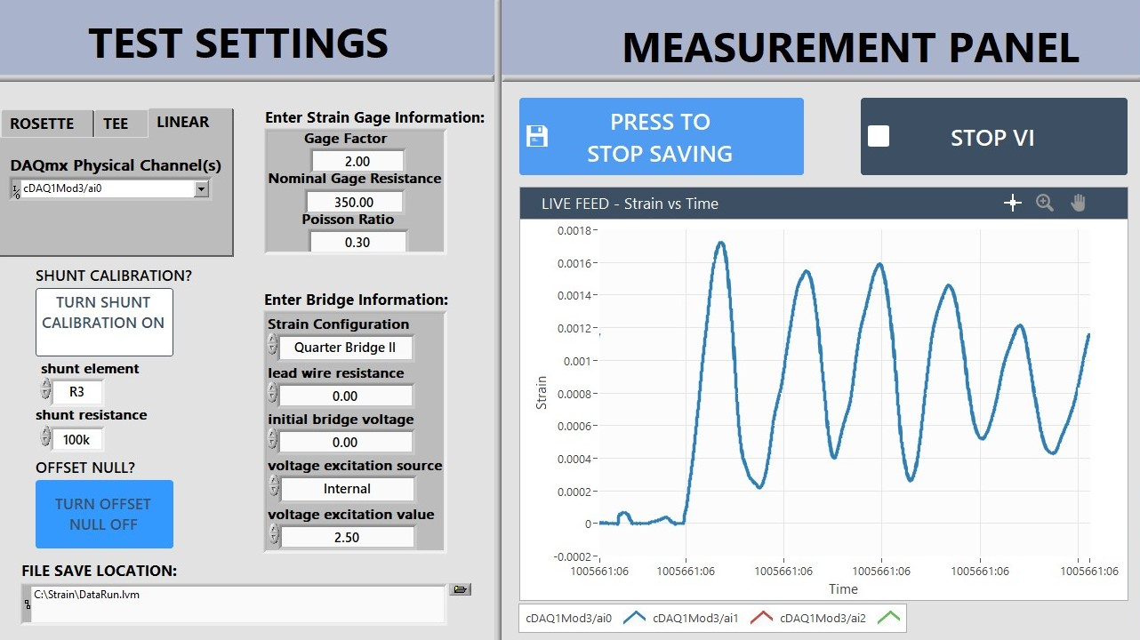

Figure 8: Screenshot from VI
- Mythbusting

The messy experience of opening an agitated can is surrounded by theories for reducing the effects of its pressurization. You will explore the validity of a few common methods of reducing the pressure in the cans after shaking them.
- 5 cans will be prepared and wired following the above steps. 3 of those cans will be shaken the other 2 will serve as controls
- Come up with some “depressurization” techniques you think will prove most effective (ex. tapping on the top, inverting, etc.)
- Begin running the VI, click PRESS TO START DATA (you may want to give the file a unique name so that data is not overwritten)
- Shake 1 of the cans for 15 seconds
- Open the can
- Click PRESS TO STOP SAVING
- Repeat steps 3-6 for 2 more cans
- Analyze the 3 depressurization techniques you used on the 5 soda cans. Which method reduced the measured strains by the most? Which method resulted in the least mess? What was the initial pressure of the cans unshaken? Record your observations.
- Compare with other groups and share your findings. Determine common effective methods between the different groups

